To: Dr. Armin Eilaghi

From: Team 3- Boeing 3D Printed Drone

Date: January 25th, 2023

Re: Project Management Report

Reflection

Project Management – Successes

Team Hi-Jacks learned a lot in the first 5 months of the capstone timeline, but a few key lessons stuck out, among others.
- The team got all the main aspects of the project figured out quickly and distributed the work amongst team members. Each team member is very clear on what they are assigned to do and when it needs to be done.
- The team were able to figure out the common time that fits everyone’s schedule to meet and discuss the deliberative of the Capstone.
- The team were able to communicate with the client and set up a few meetings with them throughout the semester to keep them updated with the project. And the team have completed all the objectives prior to the meeting to keep the promises to the client and give them accurate updates.
- The team successfully accomplished two out of four basic client requirements. The team was able to achieve the main goal of the design to get the drone below 3lb pound mark. Also, the team successfully optimized and minimized the 3D prototype as much as possible.
- The team was able to do bone tests on the material and verify that the material used for drone is appropriate for the design.

Project Management - Room for Improvements

The team have had a lot of success in the Capstone I but with the success comes the downfall through which the team have sailed smoothly. Thinking back to those failure the room for improvements are stated below:
- The main problem arises with the due dates of the assignments. Since all the team members are taking different classes throughout the semester it becomes difficult to keep track of the due dates.
- Preparation for the presentations.
- Discussion on the feedback of assignments.

Project Management - Action Items

The action items for Capstone II to improve the quality of project and not make the same mistakes that was made in Capstone I are as follow:
- Taking about due dates, the team have decided to keep track of the project in Gantt chart and updating the Timecards everyday as we process through to the project so that we have a track of due dates as well as how much of the individual deliverables are done and remaining.
- Throughout the last semester the team was assigning the slides to the students, and they had to do it by themselves which was a communication gap, and the team was forgetting to get some important papers to the presentation. But for this semester. The team has decided to get together to prepare the presentation prior to class and collect all the papers that need to be distributed in the class during presentation. Also, this will improve the flow between the slide transitions and students can potentially think about the questions asked after the presentation and prepare for that.
- The team did go through the feedback after the assignments, but it was not quiet to the extent of the discussion. The team did consider all the feedback, but they think that it needs to be taken more seriously this semester since the assignments will be more intense. Also, it will prevent the team from losing points on the same topic in next assignments or presentations and will help improve the concept of design and client requirements.

Remaining Design Efforts

The team have dominantly achieved the goal for the design concept as far as we talk about the materials and weight. The only minute things that need to be taken care of are as follow:
- Space between the discs may be a little low according to the parts that we received. So, once the team starts placing the parts on discs, they will make a call if they need to increase the space and make it a little big. If yes, in that case the only parts that need to be redesigned and reprinted will be the spacers.
- According to the design, the drone is open from the sides (360 degrees). The team was thinking of making some kind of protection of 360 degrees once the parts are placed and secured between the discs. This decision was made to protect the part from falling apart from the side or damaging in case of an impact.

Gantt Chart

In order to accurately and precisely stay on track with the completion of the Boeing Drone Capstone Project, a Gantt Chart was created (Appendix A). The appendix has only a snip of the entire Gantt Chart since the chart is too large to fit onto the document, but the chart includes all the assignments with all of the dates until the end of the project in May. The Gantt chart has all of the assignments with what each member of the team is required to complete in order to finish the assignment in order from when each assignment is due. In addition to the dates of when each assignment is due, the Gantt Chart has a completion percentage so that each member of the team can easily keep track of what still needs to be completed in order to finish the assignment. This Gantt Chart will be helpful in keeping the team organized and keeping on track to complete all of the project requirements within a timely manner. As can be seen in the appendix, the Gantt Chart is labeled in order from which assignment is due next and what every members task is for the assignment. The tasks all have percentages in order to keep track of completion and is shown on the right side of the chart where the gray bar is the amount of days the team has from the previous assignment until that assignment is due. The purple is the amount of the assignment that is completed. At the top of the chart, there is a cell that allows the users to select which week of the project that is current in order to avoid scrolling through the excel.

Purchasing Plan
As far as purchased parts go for this project, the team has purchased 15 out of 17 total parts. These 15 components have cost the team $950 and the remaining two manufactured parts cost $482 on 3D printed drone pieces. All parts required to make the drone electronically functional have been ordered and the majority have been delivered. Team Hi-Jacks will be waiting patiently on parts 10-15 from Table 1 to arrive.

Table 1: Purchased Parts for Boeing Drone as of 1/23/2023
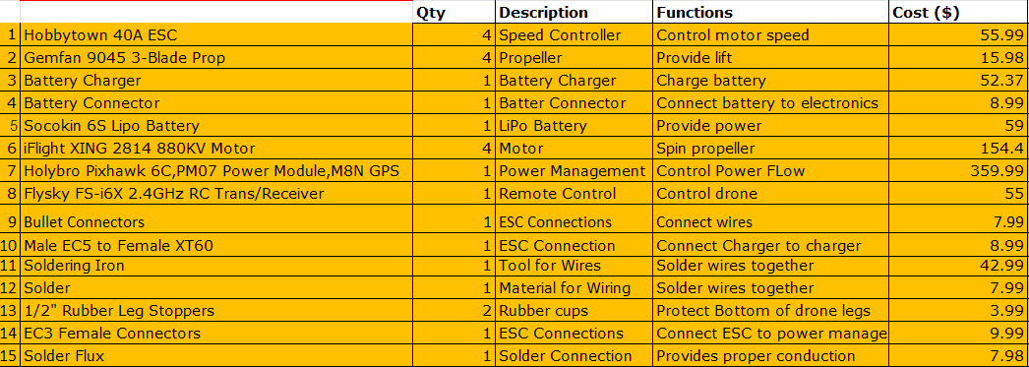

Table 2: Extra Purchasing Details about Drone Parts
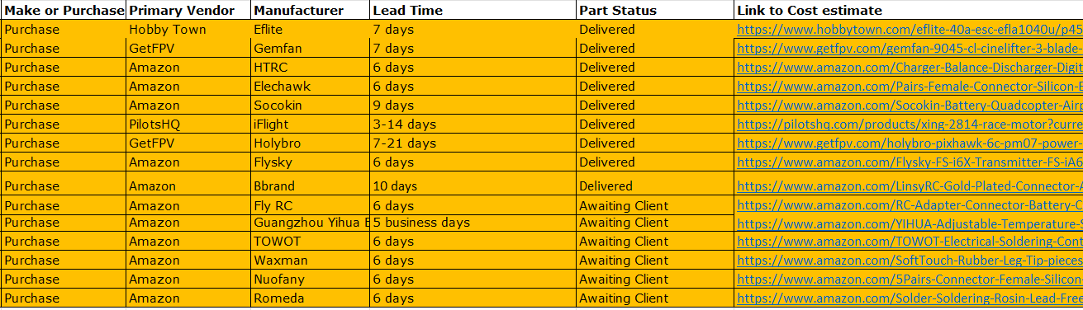

This is the first time anyone in our team has wired together a drone with motors, a power module, and an RC receiver. There was an attempt at putting all the electrical components together but found we missed some parts on the initial purchase form. Those missing parts have been submitted in a purchase form on 1/25 and plan on all packages arriving next week. Until then, the team needs to plan on doing research on drone building from scratch. Along with the building of the drone, members of the team need to learn how to program these motors to the controller as understand the speed controllers that were purchased. Ansys simulations are right around the corner and Team Hi-Jacks needs to start diving into the software for less struggle when it is time. No other purchase forms will need to be completed unless the team finds we are still missing a tool or part for the drone assembly. The next purchase form to plan for should be crash testing the drone and having a fleet of extra drone body parts for substitution.

Manufacturing Plan
This plan shown in table 3 details the plan for each of the manufactured parts. The plates, arms, legs, and spacers have the description, quantity, along with the who, what, when, and where. Each part requires work which is detailed above photo.

Table 3: BOM of manufactured parts
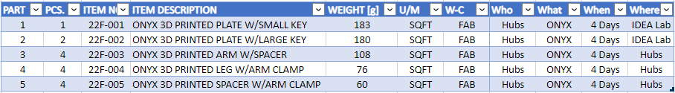

Action Items
- Plate with small key
- Add indents in plate where parts will be placed
- Agree on final thickness
- Agree on final diameter

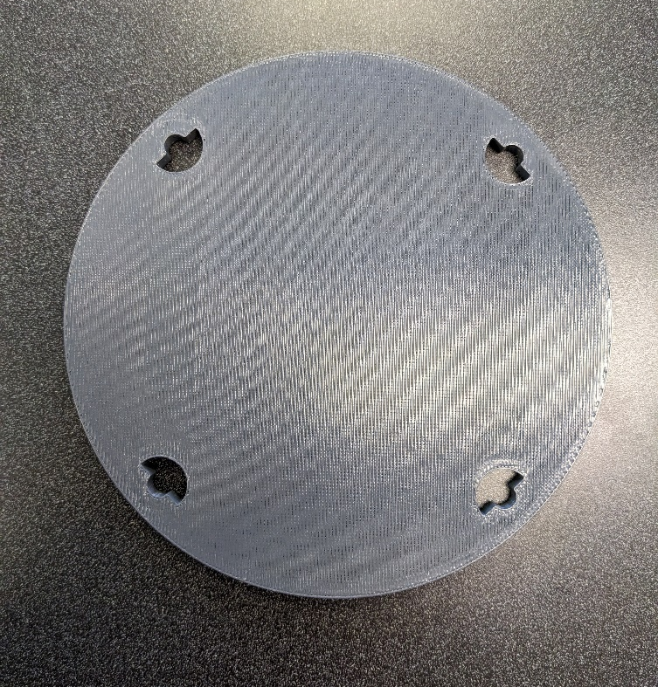
Figure 1: Plate with small keyway

- Plate with large key
- Add indents in plate where parts will be placed
- Agree on final thickness
- Agree on final diameter

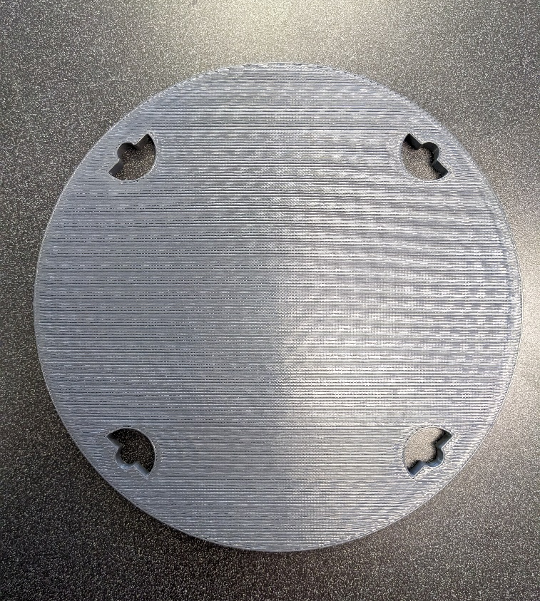
Figure 2: Plate with large keyway

- Arm with spacer
- Increase length
- Increase size of mount in every dimension
- Add speed controller mount

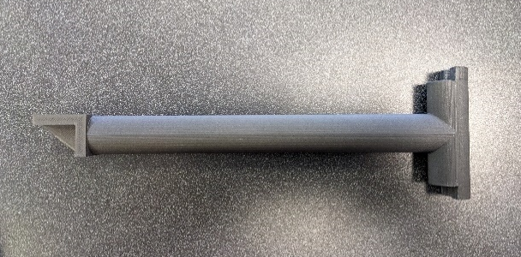
Figure 3: Arm with spacer and keys
- Leg with arm clamp
- Round off edges and make concentric with bolts for material and weight savings

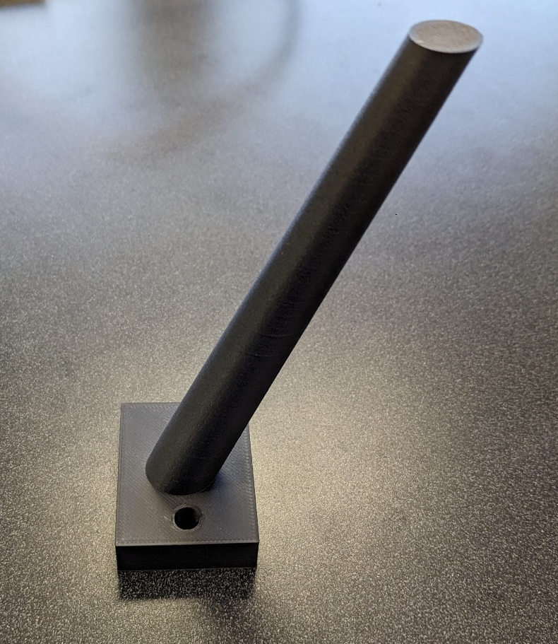
Figure 4: Leg with arm clamp

- Spacer with arm clamp
- Round off edges similar to the leg

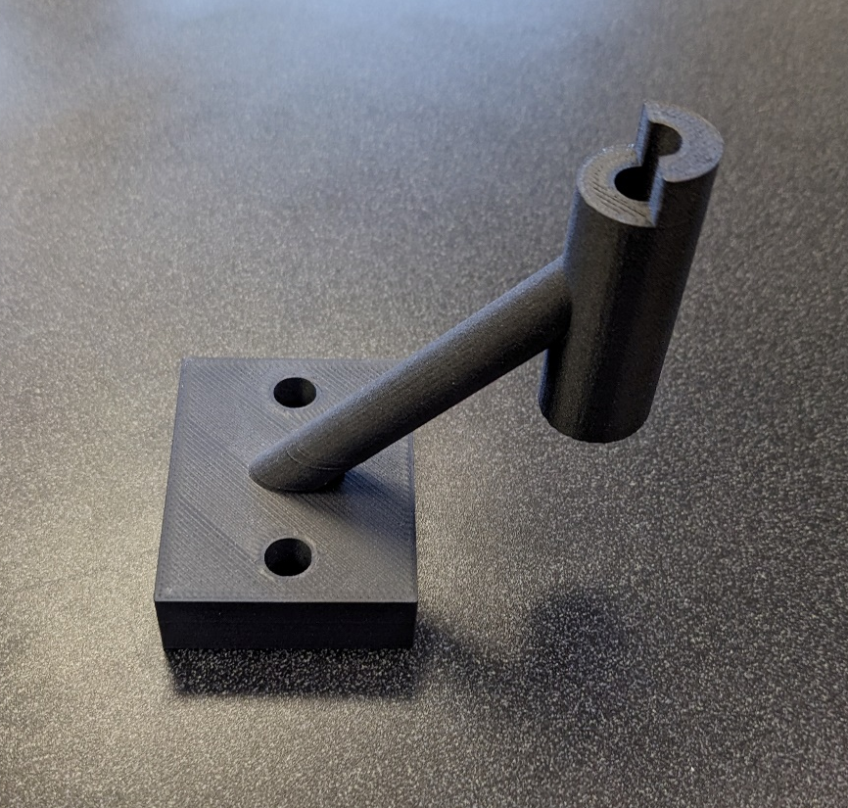
Figure 4: Spacer with arm clamp

Appendix A: Gantt Chart Snip

